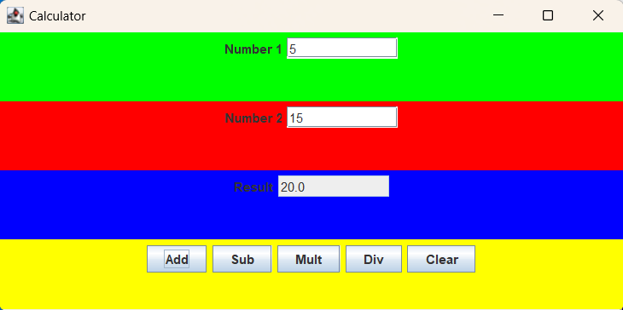

package as12;

public class TestJFrameExt
{
public static void main(String[] args)
{
//create a JFrameExt object i.e. a frame or window
JFrameExt f = new JFrameExt();
//set the title, size, and visibility of the frame
f.setTitle("Calculator");
f.setSize(600, 300);
f.setVisible(true);
}
}

